HookLever INSTALLATION
The Hooklever™ components included in price are: long swage stud, ring band, locknut, Hooklever unit, D-link, strap toggle.
For standard 1/19 wire in sizes 6, 7 or 8mm wire.
Recommended stay length of up to 12.1m. (A man can tension the stay to within 45mm manual deflection).
Swage stud to be swaged on to wire by a rigger.
Note for riggers: To determine the wire cut length, set threaded adjustment to 40% closed
(30mm) then heave wire down manually with intent and mark cut length. On most rigs this
will result in a 75% (56mm) bury under tension.
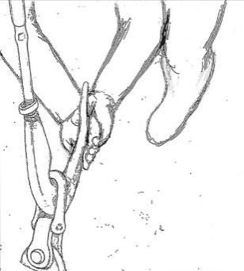
The best technique for The Hooklever™ is pushing the lever over-centre with heel of left hand taking most of the weight and elbow braced against knee.

Fitting to a padeye on deck
To fit to a padeye on deck, the strap toggle is not applicable, instead a D-shackle with centring bush (available) may be used.
Inside clearance of padeye needs to be 23 mm diameter minimum to allow fit.
When fitting a padeye, choose a double folding padeye for the stay and tack-shackle of the sail.
Fitting a babystay
When The Hooklever™ is fitted for a babystay, a D-shackle (available) can be fitted with spacer washers to centre it. The pin size/diameter of the D-shackle is 12mm.

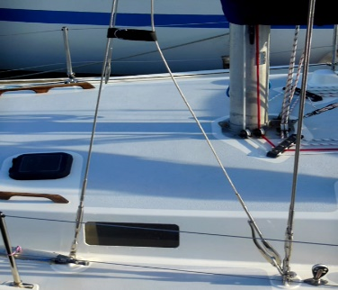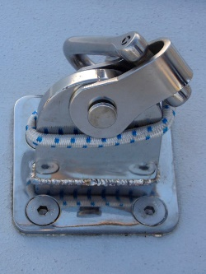
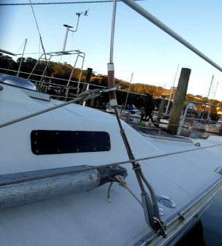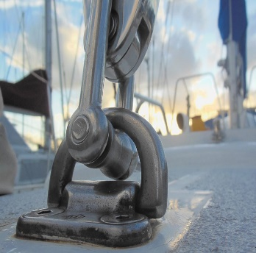
For setting a storm jib, staysail on a removable cutter-stay or a Solent jib, to improve sail performance when reefed or as a backup to roller furling systems. The Hooklever™, like the Highfield lever, is a mechanical tensioner with over-centre force. When short-tacking often, making the inner forestay removable becomes desirable to free the foredeck.
- Do NOT apply extensions such as pipe or bar to the lever.
- Not to be used for human suspension.

